PRAISE GOD! We raised $4550 for Take the Next Step through this project!!!!!!

Matching Gifts for Take The Next Step

We are blessed to be in a community with wonderful Christian organizations that serve people in need. As God's people, I want to encourage you to help us serve Take the Next Step in this time of need. We have $1000 in our mission budget from this fiscal year that we want to use to encourage donations to Take the Next Step. So, until July 28, we will match any donations from our congregation until we get to that $1000 limit. You have been so generous in this time of COVID, let's continue to use God's money to make a difference in our community. Just send a check or donate online (https://give.cornerstone.cc/peacemonroe) with your donation marked, "Take the Next Step". Thank you.

Jesus is with you,

Todd
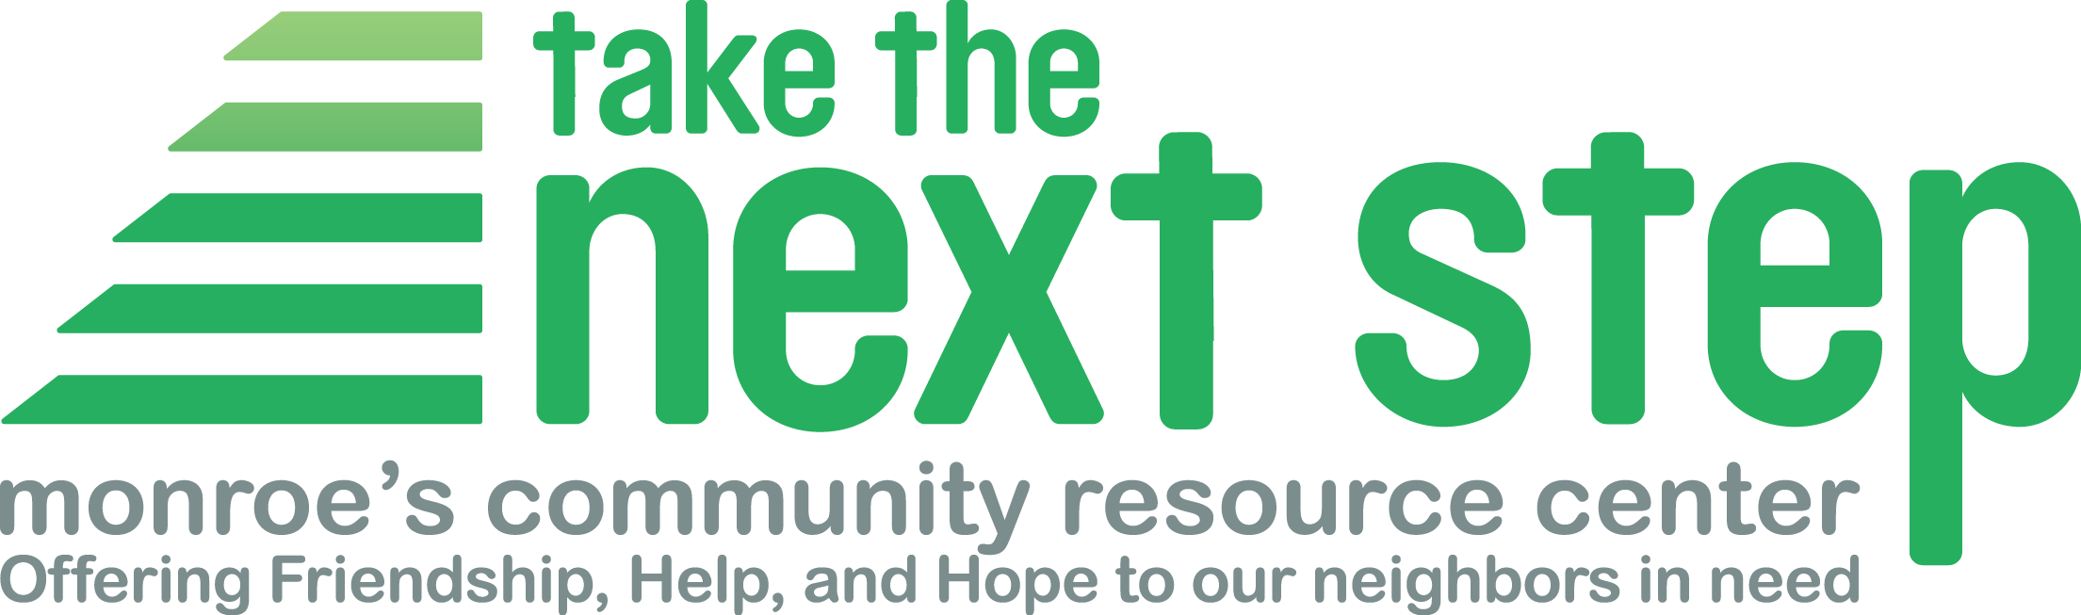

Dear friends and supporters,
Thank you for being a partner in Take the Next Step’s work!
As we come into the fourth month of the COVID-19 crisis, we hope you and your loved ones are staying healthy and safe in this difficult time.
Nonprofits like Take the Next Step have a huge role to play through and after this crisis. Our usual ways to care for our community’s most vulnerable families, mobilize people, and raise funds will not be available for what could be a very long time. So, we have developed many creative ways to connect, learn, inspire, and keep moving forward in our vital work of assisting our neighbors in these unprecedented and difficult times.
Our work did not stop with the virus and must continue long after this crisis is behind us, too.
The Next Step needs to be here when this crisis is over.
We hope you will prioritize taking care of yourself and your family’s health while also realizing the dire situation our unhoused, low-income, and vulnerable neighbors face.
In the best of times, the families we serve live paycheck to paycheck with little margin for emergencies.
Now, through no fault of their own, they suddenly have no paychecks. At the same time, bills are mounting and resources for their daily survival are dwindling… or gone.
It’s challenging for us, too. Our individual donations have fallen by nearly one third - donations we use to cover our program costs and staff salaries. Fortunately, we received eight weeks of payroll coverage through the CARES Act Payroll Protection Plan…but that support ends this month. Please help us make up for this disastrous drop in income so that we can continue our work.
At Next Step we’ve overhauled everything we do to meet the current and changing needs in a safe way. We’re working harder than ever.
Please take a moment to visit our webpage “How we’re working in the time of the virus…” to discover how we continue to meet the needs of our community in new and creative ways.
This is the time we usually invite you to our annual Spring Fundraiser Lunch - we’ll miss you!
We’re sorry we can’t have lunch with you, but you can still support the work of Take the Next Step through this critical time. We hoped to raise $30,000 this year.
As a grassroots organization, we depend upon your financial support to continue our work during this time of the virus.
We know that together we can help keep Monroe’s most vulnerable families and individuals afloat and most importantly, alive, during this difficult time. Through this all, we will rise by lifting others.
We ask, if you have the means to give, to please do so at this time. If you give regularly, will you please consider increasing your donation through this time of crisis? If you would have given at the fundraising event, please consider doing so now. There are many ways to give!
And please, remember we are all in this together. Please do be kind during this time of great stress.
Kindness will go a long way.
Stay well and be safe my friends,
Sarah Lunstrum
Community Outreach and Volunteer Coordinator

